UE41719-BR REPLACEMENT UPGRADE UNIT ELECTRICAL CONNECTION

The replacement unit will differ slightly with regards to its electrical connection from the original unit. Please follow the instructions below for connection of the new alternator into the existing vehicle loom.
The new unit is also supplied with a replacement regulator box, this is internally modified to act as a bypass, so using the new alternator unit’s internal voltage and current regulation.
The bypass regulator box should be connected exactly the same as the OE unit connecting all cables as per their location on the OE unit. A, WL, F etc.

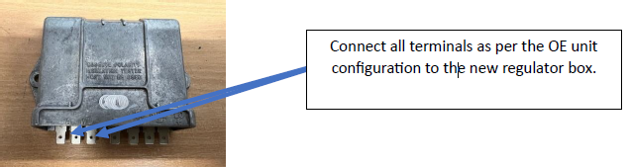

The original alternator unit has two cables with spade terminals, these labelled in the picture below A and F. The A cable connection is not used in the new alternator application and must be insulated and tied back into the loom.

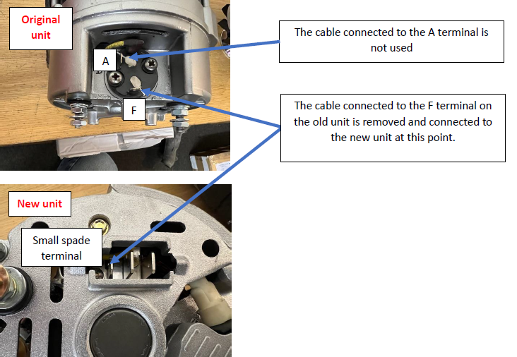

The spade terminal will be the same size on both alternator units.
UE41719-BR REPLACEMENT UPGRADE UNIT ELECTRICAL CONNECTION (cont)
There are two other connections connected to the original unit these are the battery positive and an earth connection. These must be removed and connected to the new unit as show in the lower picture below.

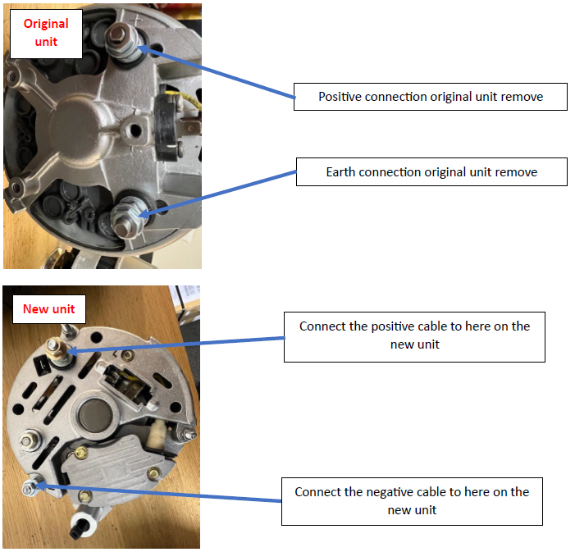

If in doubt, please contact us!
=

