AUXILIARY WATER PUMP KIT
3Z0198953A-BR
Version 1.0 10/01/23

Unlike the Bentley auxiliary water pump kit (which is not suitable for Arnage Red Label and Arnage le Mans), the Brabo Parts kit contains all the components required to replace the original pump with an uprated, and larger equivalent.
The kit is suitable for Arnage Red Label. Arnage Le Mans, Arnage R, Arnage RL, Arnage T, Arnage Blue Train, Arnage Diamond Series, Azure (2006-2010) & Brooklands Coupe.
Arnage Red Label & Arnage Le Mans
The two hoses PG107215PC-BR & PG107218PC-BR may be discarded. Use the straight hoses, metal reducers and clips to attach the original straight hoses to the auxiliary pump:
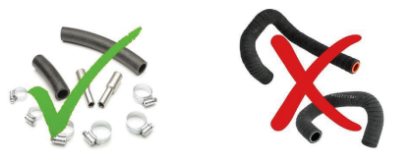

Arnage R, Arnage RL, Arnage T, Arnage Blue Train. Arnage Diamond Series, Arnage Final Series, Azure (2006-2010) & Brooklands Coupe
The straight hoses and reducers may be discarded. The two moulded hoses are flared to fit the later style pump and may be used in place of the original inlet and outlet hoses, where the diameter is too small to fit the pump ports:
